**Sakila Exercise**

Download the sakila database SQL scripts here: [sakila database](https://downloads.mysql.com/docs/sakila-db.zip)

Run the sakila-schema and the sakila-data scripts (in that order). The schema of the sakila database is as follows:

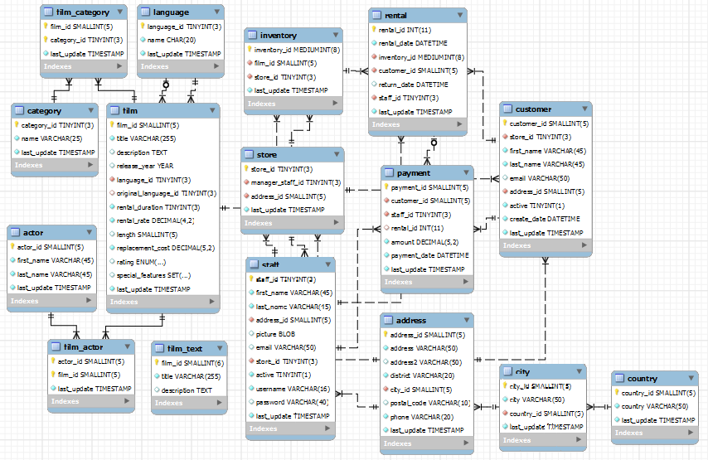

Using SQL, find out the following:

1. Count how many actors there are for the movie 'HAUNTING PIANIST'.
2. Count how many Mandarin movies there are for each store.
3. Return the names of the customers who has spent more than 20 dollars from rentals.
4. Return the count of 'PARK CITIZEN' movies in the inventory.
5. Count how many rentals there are for the movie 'CHICKEN HELLFIGHTERS'.
6. Count how many customers there are from the 'Sichuan' district.
7. Return the country with the postal code 49757.
8. Count how many movies of category 'Comedy' are in the store with id = 2.
9. Return the names of the movies that BURT DUKAKIS has been in.
10. Return the names of the movies that have the rating 'PG' that are in the store with id = 1.